Chapter 19, Solution 61.

- To obtain 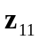 and 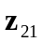, consider the circuit in Fig. (a).
1 
1 
+
V₂
−
I₁
I₂ = 0
(a)

1 
1 
+
V₁
−
I_{o}

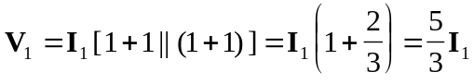
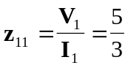

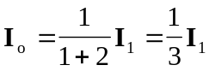

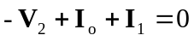
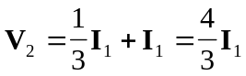

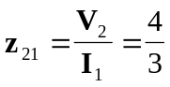

To obtain 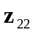 and 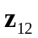, consider the circuit in Fig. (b).
1 
1 
(b)

1 
1 
+
V₁
−
I₁
+
V₂
−
I₂

Due to symmetry, this is similar to the circuit in Fig. (a).


 